**Overview of COVID-19**

This overview is an attempt to provide some context and clarity around the COVID-19 outbreak and to avoid some of the noise and “bite-size” information that is flowing through traditional mainstream media outlets. Please note that the “media” discussion is simply regarding the speed of information flowing and the lack of a “contextual” approach to what is happening around the globe due to that speed.

***30K Foot View***

* The risk assessment for most of the world remains very low according to the World Health Organization (WHO). The WHO and Center for Disease Control (CDC) will be referenced throughout this overview.

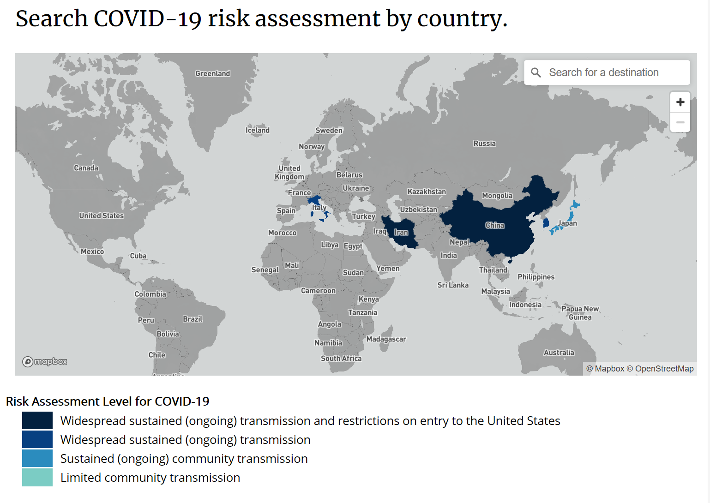

* **The CDC issues Travel Warnings from:**
* ***Level 4*** (No Travel)
* ***Level 3*** (Avoid all Non-Essential Travel)
* ***Level 2*** (Take Extra Precautions – Elderly, Chronically sick)
* ***Level 1*** (Normal Travel Precautions).
* ***Current Global Status:***
* ***Level 3*** – (China, Iran, S. Korea, Italy)
* ***Level 2*** – Hong Kong
* ***Level 1*** -Japan

**There are NO Travel Warnings for travel within the United States**

* Recoveries are outpacing new cases and have been since February 19th. This is an important piece to the story that has not been emphasized enough.

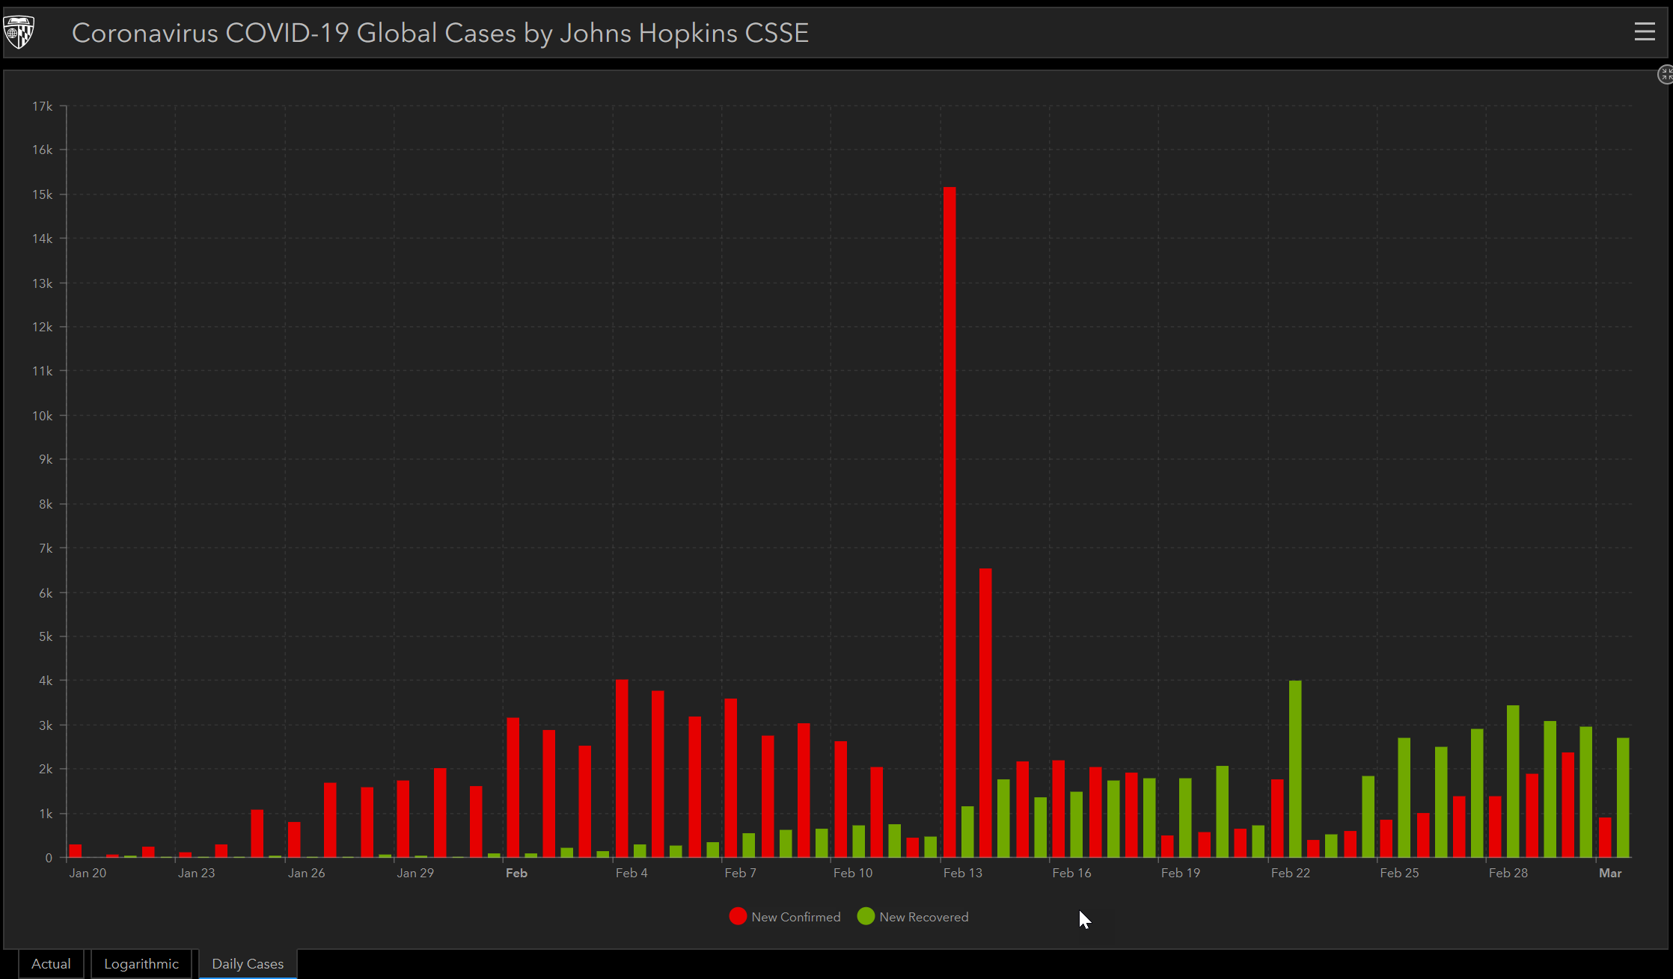

* Another visual that shows China, Recoveries and Rest of the World

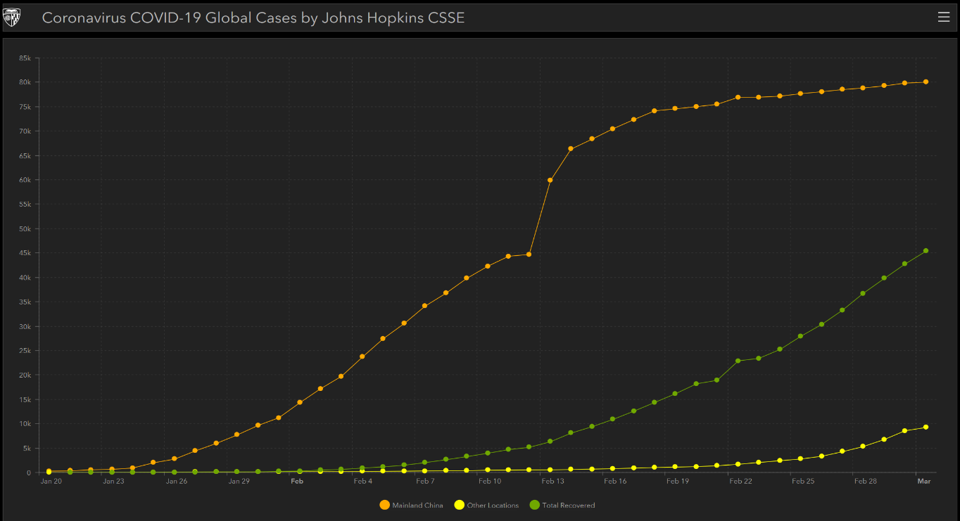

* We tend to ignore the “Epidemic Curve” which is highlighted below and very evident when you start to look at the peak and control in different areas as is shown in this report from the Hong Kong Centre for Control Prevention.

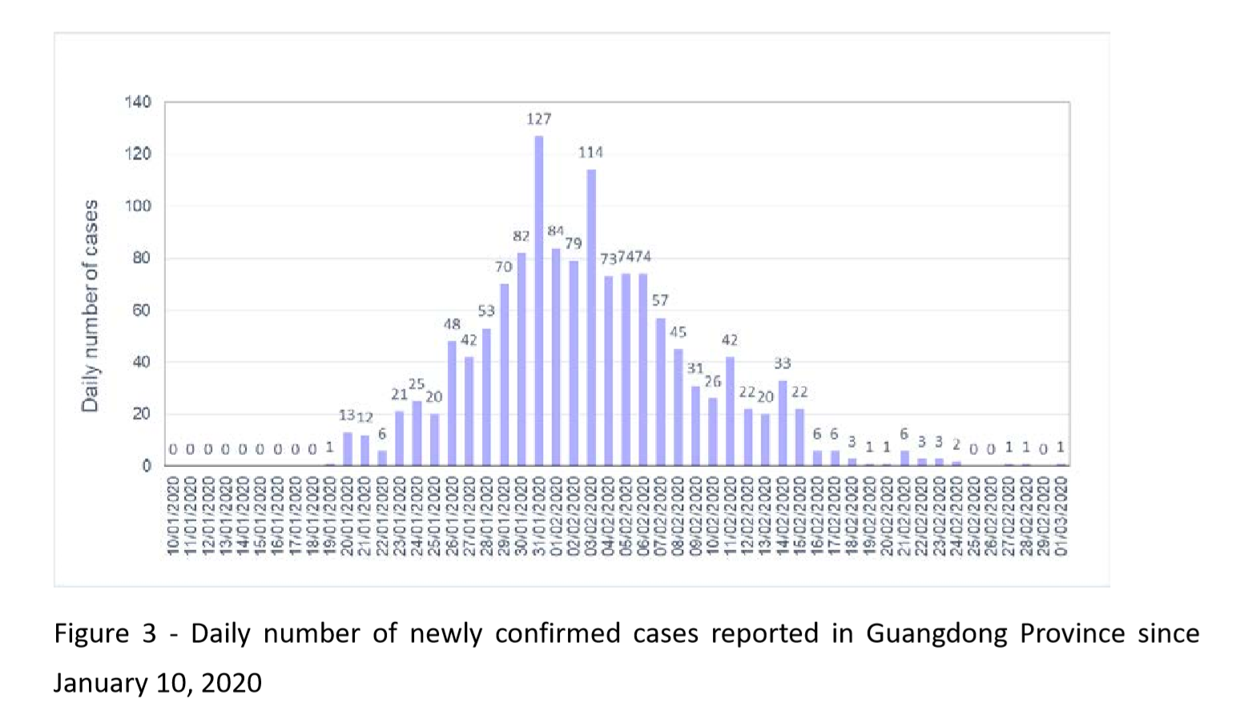

***Perspective & Context***

* The head of the WHO today at his press conference made some points that have been largely overlooked and had a call for perspective. The next paragraph is about that perspective.
* Head of WHO
* “We need to see this in perspective. Of 88,913 cases reported globally so far, 90% are in China, mostly in one province.”
* “Of the 8,739 cases reported outside of China, 81% are from 4 countries.”
* “Of the other 57 affected countries, 38 have reported 10 cases or less, 19 have reported only one case, and a good number of countries have already contained the virus and have not reported in the last two weeks.”
* **“We are in uncharted territory. We have never before seen a Respitory pathogen that is capable of community transmission, but which can also be contained with the right measures. If this was the influenza epidemic, we would have expected to see widespread community transmission across the globe by now, and efforts to slow it down or contain it would not be feasible”**
* **Link to full transcript is below:**

<https://www.who.int/dg/speeches/detail/who-director-general-s-opening-remarks-at-the-media-briefing-on-covid-19---2-march-2020>

* Wuhan (ground zero) which has 79K cases has a population of 11 million people. This is an infection rate of 0.7%. This is a very small part of the overall population in Wuhan.
* The infection rate of Italy with a population of 60 Million people does not even register at 0.1%.
* Your risk of contracting the virus is 1 in 100K. Your risk of being struck by lightning is 1 in 3K. This is not an attempt to make lite of the virus, but to offer perspective around the risk.

***Context***

* There have been 3K deaths globally with the CoronaVirus. Yes, every loss is tragic and should have perspective. Context around death rates are also important in times like this.
* ***Annual Mortality rates around disease, offers context:***
  + Measles – 140K annually
  + Influenza (The Flu) – 650K annually
  + Tuberculosis – 1.5 Million annually
  + Gastroenteritis infections – 1.8 Million annually
* This context is why there is a belief that we have a “Pandemic of Fear” that has been created with the way things have been portrayed. With 2019 being the worst flu season, we have seen – why has that not been presented the same way.

***Influenza***

When comparing to the flu, people will argue that we have a vaccine for the flu, so it is not the same comparison.

* Less than 50% of all Americans get the flu vaccine although it will kill 16K people annually at a minimum
* The flu vaccine does not keep us from getting the flu (unlike the Polio or Measle vaccines) and 30% of those that die from the flu had received the vaccine.
* The flu like COVID-19 is a virus so that antibiotics will not be effective in treating and thus have a similar life span.
* Below you will find a chart outlining the 2019 -2020 Flu Season and those most at risk. The at-risk chart is the same for both the COVID-19 and the Flu.
* When reviewing the high-risk categories – they remain constant.

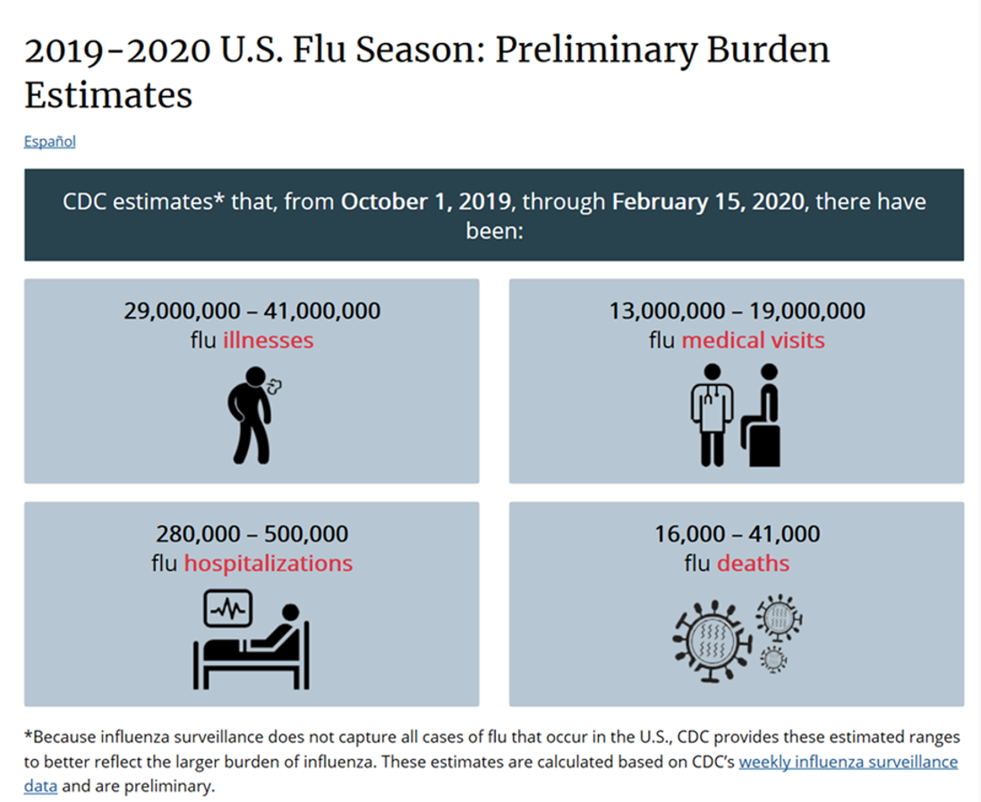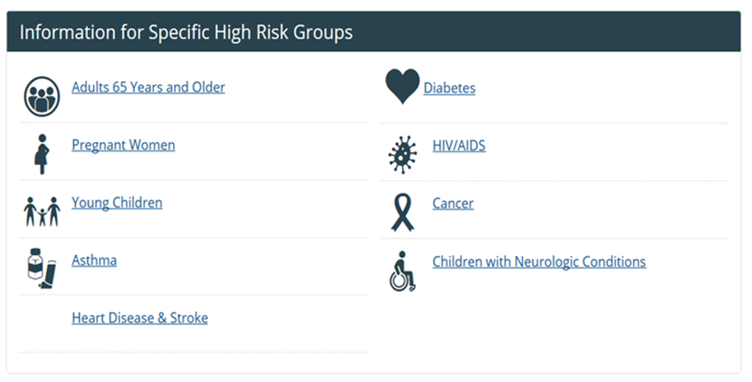

***Meetings Industry***

* Although there have been some high-profile meetings that have cancelled or postponed, the question is around their global make-up and what countries were impacted with many of these programs. You also need to consider the short-term timelines and they were in some cases problematic.
* What isn’t as widely reported are the thousands of meetings that are continuing as the World Pet Expo and today’s announced IMEX Frankfurt are some high-profile examples.
* It is important to know that with out world travel restrictions – the “impossibility” that is necessary for Force Majeure is not in play.
* Outside of the few areas listed above, travel and life in general are progressing quite normally.

***Final Thoughts***

It is understood that many of the decisions and items are under review by many stakeholders. The goal here was to lay out what “is” and what “isn’t” around the COVID-19 outbreak.

Yes, there remains a “Pandemic of Fear” and there is so much mixed information being shared without context or perspective. The goal of this recap was to provide some clarity and serve as a reference tool as of March 2nd.

When we discuss a “hysteria” around this virus and travel it is interesting how “travel” has been the piece that has been focused on so Intensely.

To think that just last night on Sunday, March 1st there were 7 NBA games around the country, 11 Division 1 Men’s NCAA games, not to mention this weekend the thousands of youth sports events that parents attended with their children. All were in enclosed areas - with many handrails being touched, seated next to hundreds and thousands of people for an event.

When we travel, we tend to focus on washing of hands and being aware. Not so much in just everyday life.

Again, perspective is just so important right now specifically.